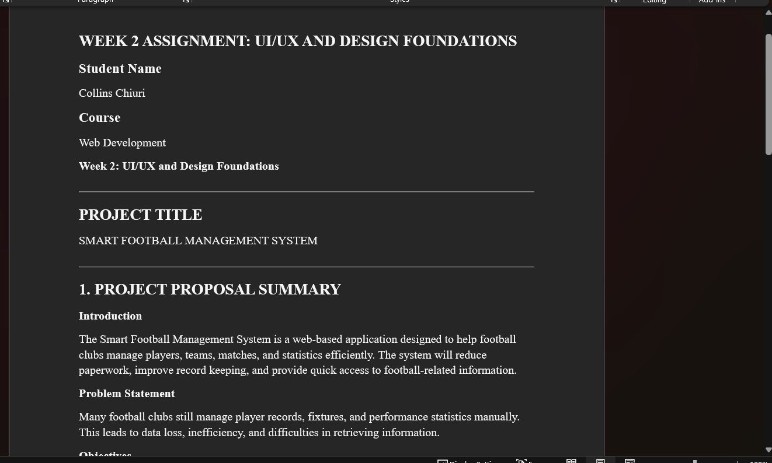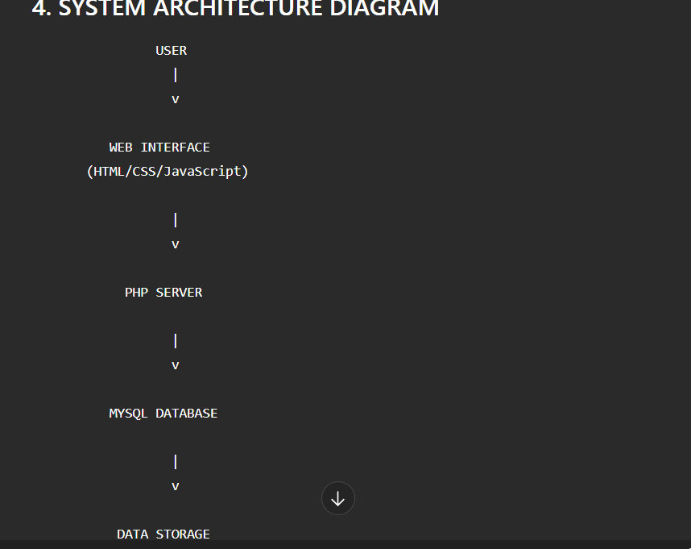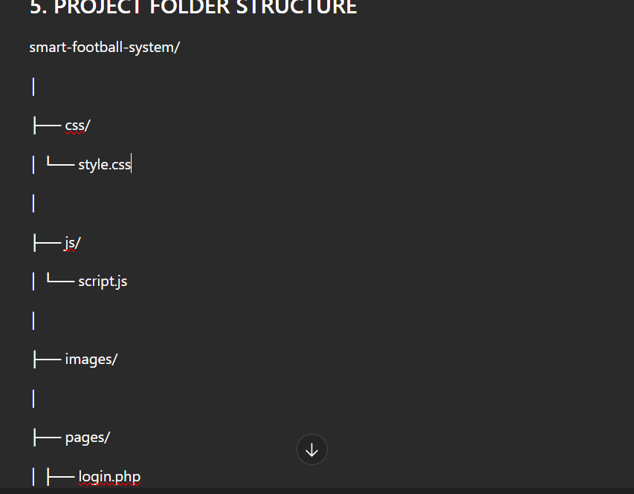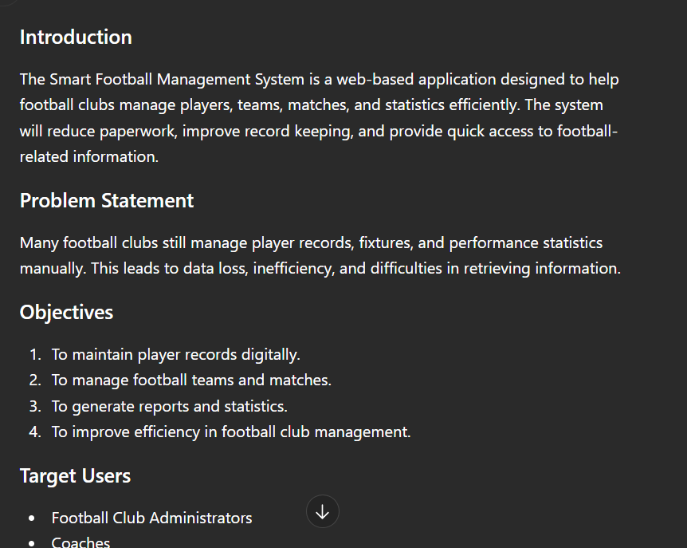

Lesson
The design was selected because it is simple, user-friendly, and suitable for managing football-related information efficiently. User experience was a key consideration, with clear layouts, readable fonts, consistent colors, and easy-to-use navigation menus. The navigation flow was planned to allow users to move smoothly between the homepage, login page, dashboard, and other system features with minimal clicks. This reduces confusion and improves usability. The intended users of the system include football fans, team managers, coaches, and administrators who need quick access to football statistics, player information, match schedules, and other relevant data.

